1. 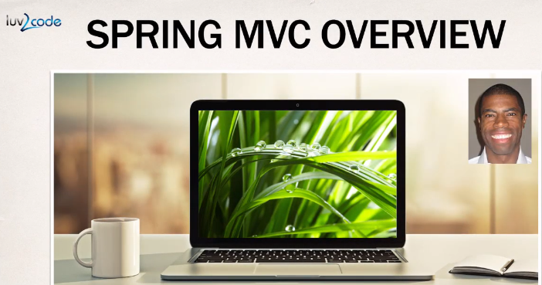
2. 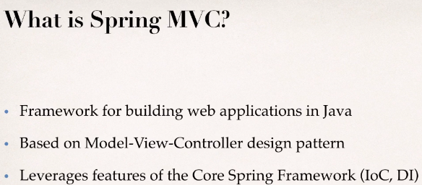
3. Following is the big picture of **Spring MVC Framework**, and the **process flow** & how it works.
   1. Browser request comes to **spring mvc front controller** & it **delegates** the request to controller code created by you containing **business logic**
   2. You create model and send back to front controller & front controller sends the model over to your **view template**.
   3. Your view template is basically html or jsp taking model, rendering a response to the browser.
4. 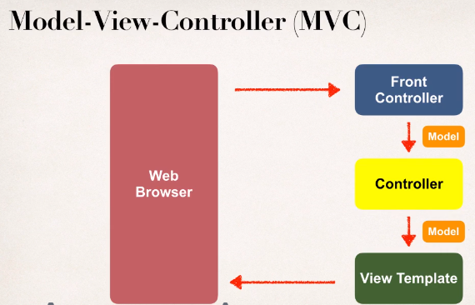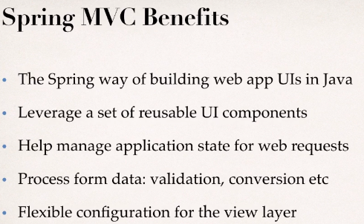
5. **Reusable UI Component**s: Are available in the form of Spring JSP Custom Tags.
6. **State**: Session Tracking, Application Tracking.
7. 